**TEST NG XML Suite Files**

1. Test NG Batch Execution suite – testing.xml

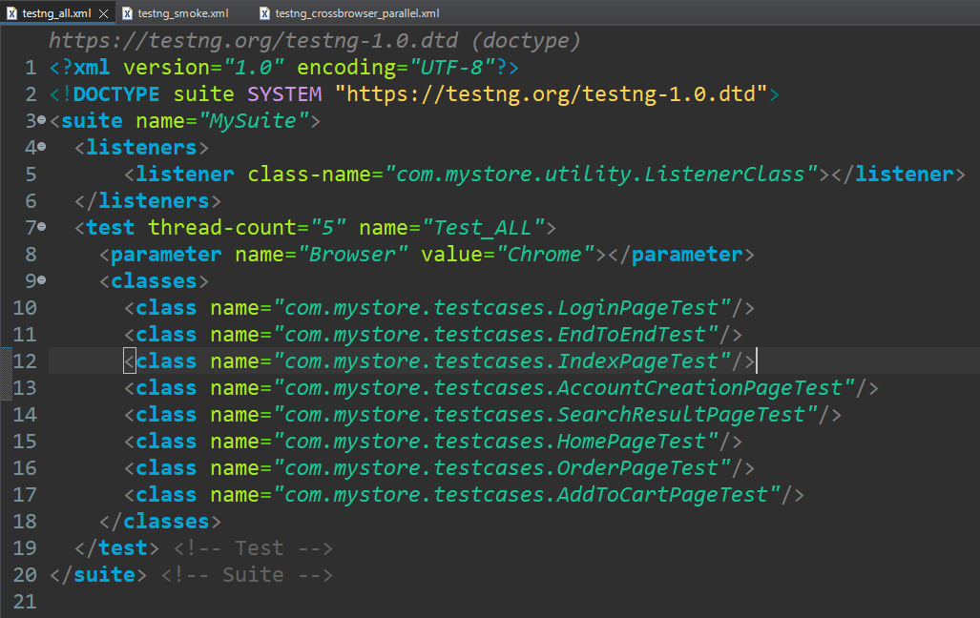

<?**xml** version=*"1.0"* encoding=*"UTF-8"*?>

<!**DOCTYPE** suite SYSTEM "https://testng.org/testng-1.0.dtd">

<**suite** name=*"MySuite"*>

<**listeners**>

<**listener** class-name=*"com.mystore.utility.ListenerClass"*></**listener**>

</**listeners**>

<**test** thread-count=*"5"* name=*"Test_ALL"*>

<**parameter** name=*"Browser"* value=*"Chrome"*></**parameter**>

<**classes**>

<**class** name=*"com.mystore.testcases.LoginPageTest"*/>

<**class** name=*"com.mystore.testcases.EndToEndTest"*/>

<**class** name=*"com.mystore.testcases.IndexPageTest"*/>

<**class** name=*"com.mystore.testcases.AccountCreationPageTest"*/>

<**class** name=*"com.mystore.testcases.SearchResultPageTest"*/>

<**class** name=*"com.mystore.testcases.HomePageTest"*/>

<**class** name=*"com.mystore.testcases.OrderPageTest"*/>

<**class** name=*"com.mystore.testcases.AddToCartPageTest"*/>

</**classes**>

</**test**> <!-- Test -->

</**suite**> <!-- Suite -->

1. Test NG Smoke Tests Group Suite –

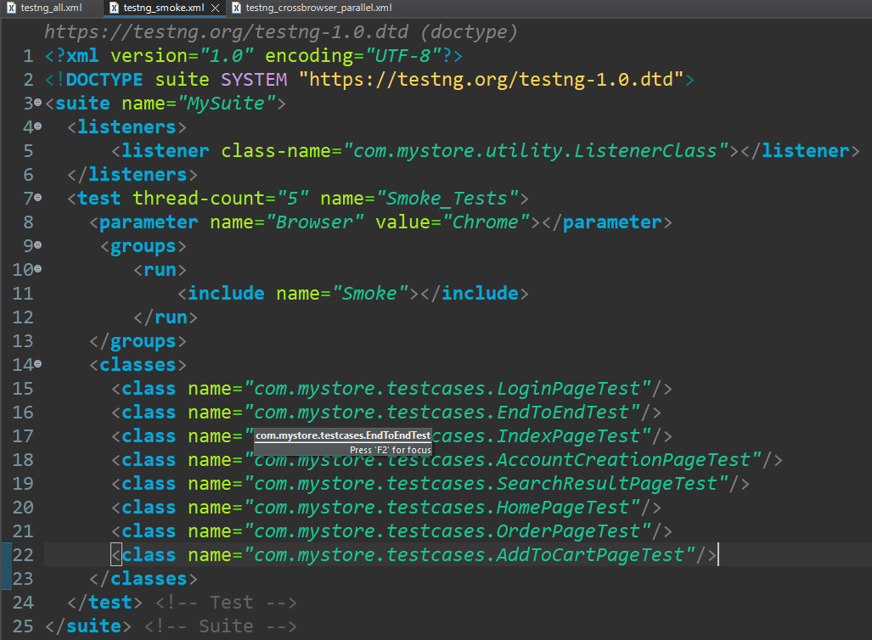

<?**xml** version=*"1.0"* encoding=*"UTF-8"*?>

<!**DOCTYPE** suite SYSTEM "https://testng.org/testng-1.0.dtd">

<**suite** name=*"MySuite"*>

<**listeners**>

<**listener** class-name=*"com.mystore.utility.ListenerClass"*></**listener**>

</**listeners**>

<**test** thread-count=*"5"* name=*"Smoke_Tests"*>

<**parameter** name=*"Browser"* value=*"Chrome"*></**parameter**>

<**groups**>

<**run**>

<**include** name=*"Smoke"*></**include**>

</**run**>

</**groups**>

<**classes**>

<**class** name=*"com.mystore.testcases.LoginPageTest"*/>

<**class** name=*"com.mystore.testcases.EndToEndTest"*/>

<**class** name=*"com.mystore.testcases.IndexPageTest"*/>

<**class** name=*"com.mystore.testcases.AccountCreationPageTest"*/>

<**class** name=*"com.mystore.testcases.SearchResultPageTest"*/>

<**class** name=*"com.mystore.testcases.HomePageTest"*/>

<**class** name=*"com.mystore.testcases.OrderPageTest"*/>

<**class** name=*"com.mystore.testcases.AddToCartPageTest"*/>

</**classes**>

</**test**> <!-- Test -->

</**suite**> <!-- Suite -->

1. Test NG Cross Browser Parallel Tests Suite –

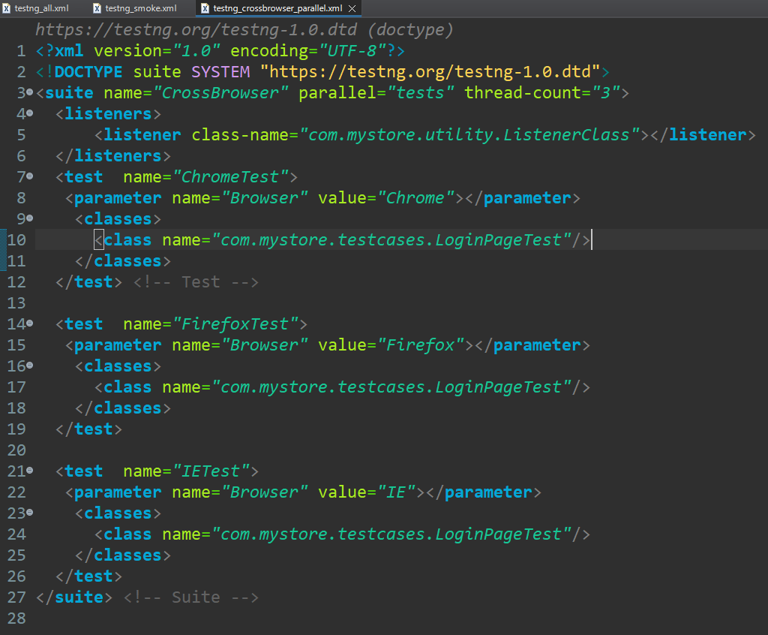

<?**xml** version=*"1.0"* encoding=*"UTF-8"*?>

<!**DOCTYPE** suite SYSTEM "https://testng.org/testng-1.0.dtd">

<**suite** name=*"CrossBrowser"* parallel=*"tests"* thread-count=*"3"*>

<**listeners**>

<**listener** class-name=*"com.mystore.utility.ListenerClass"*></**listener**>

</**listeners**>

<**test** name=*"ChromeTest"*>

<**parameter** name=*"Browser"* value=*"Chrome"*></**parameter**>

<**classes**>

<**class** name=*"com.mystore.testcases.LoginPageTest"*/>

</**classes**>

</**test**> <!-- Test -->

<**test** name=*"FirefoxTest"*>

<**parameter** name=*"Browser"* value=*"Firefox"*></**parameter**>

<**classes**>

<**class** name=*"com.mystore.testcases.LoginPageTest"*/>

</**classes**>

</**test**>

<**test** name=*"IETest"*>

<**parameter** name=*"Browser"* value=*"IE"*></**parameter**>

<**classes**>

<**class** name=*"com.mystore.testcases.LoginPageTest"*/>

</**classes**>

</**test**>

</**suite**> <!-- Suite -->